Power electronics project part b

Prepared by :
Tadala Mitumbili
Due Date :
11 May

Question 1
- Calculations
$$Z_{n}=\frac{R}{1+jωRC}$$
$$∠Z= -arc\tan{(wRC)}$$
For the DC component
V_{dc} = 3 x 100 = 300 V
For first harmonic
$$Z_{1}=\frac{100}{1+j*120π*100*50×{10}^{-6}}$$
$$Z_{1}=46.86∠-62.05° Ω$$
$$V_{1}=\sqrt{2}V_{1rms}=\sqrt{2}V_{1rms}I_{rms}=\sqrt{2}*\frac{4}{\sqrt{2}}*46.86=187.44$$
$$v_{1}\left(t\right)=187.44\cos\left(2π*60t-62.05°\right)$$
For second harmonic
$$Z_{1}=\frac{100}{1+j*240π*100*50×{10}^{-6}}$$
$$Z_{1}=25.64∠-75.14° Ω$$
$$V_{1}=\sqrt{2}V_{1rms}=\sqrt{2}V_{1rms}I_{rms}=\sqrt{2}*\frac{6}{\sqrt{2}}*25.64=153.84$$
$$v_{1}\left(t\right)=153.84\cos\left(2π*60t-75.14°\right)$$

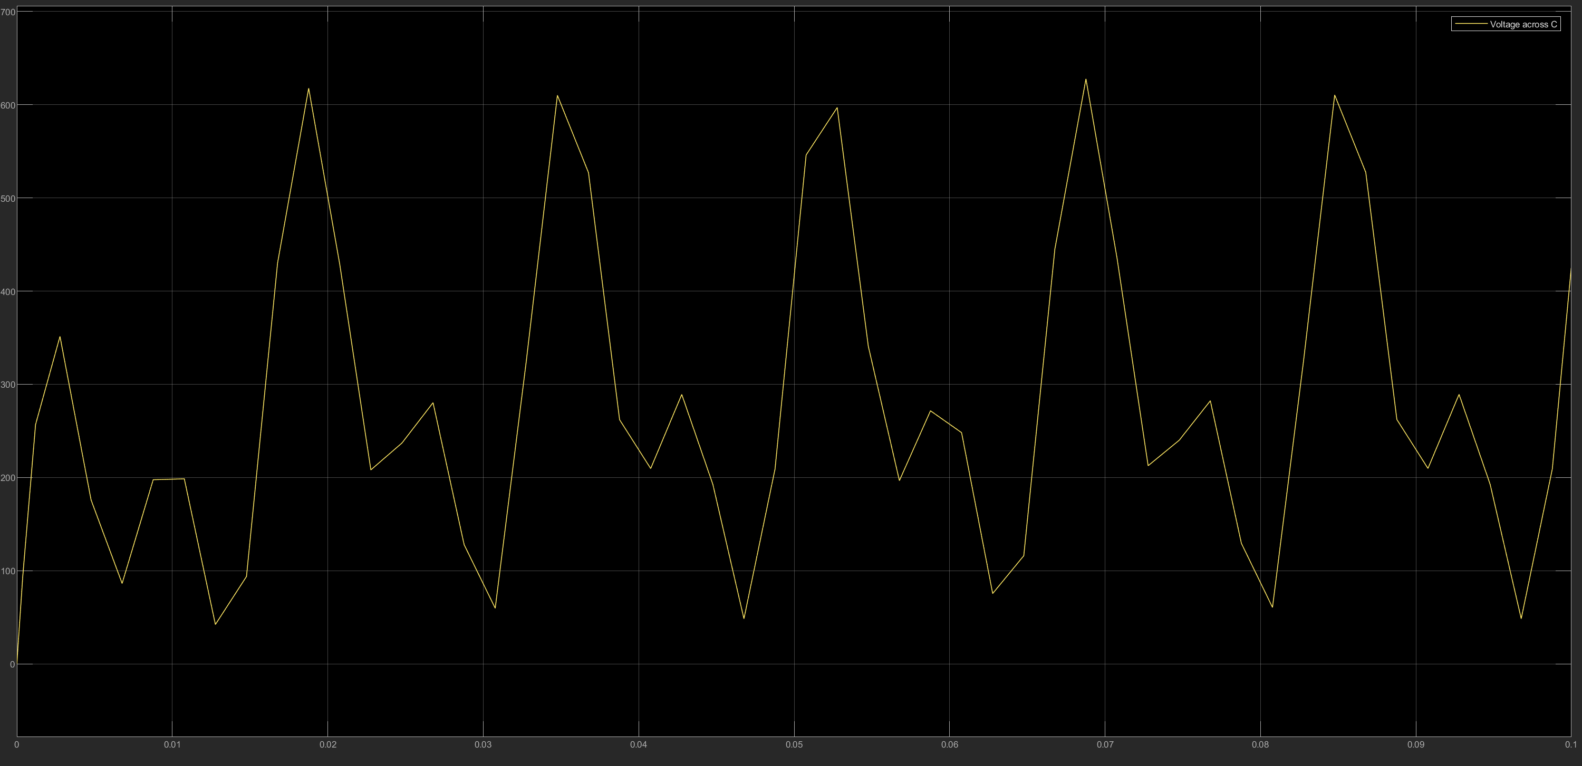
Figure 1 voltage waveform across c

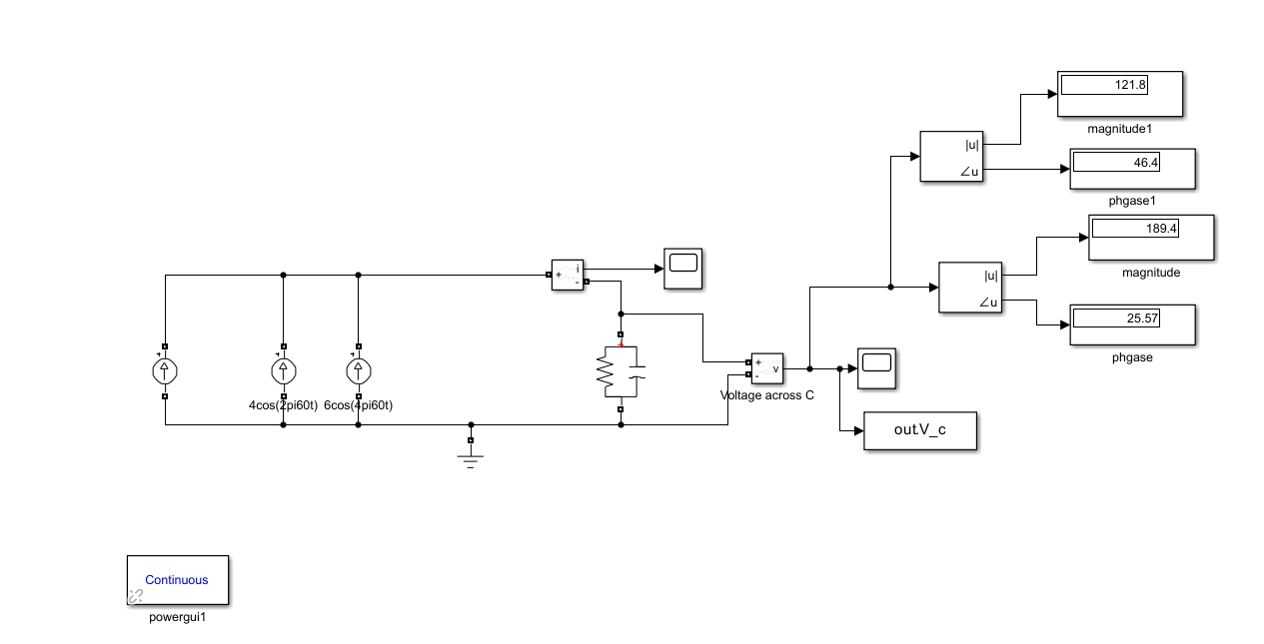
Figure 2 phase and magnitude of 1st and 2nd harmonics
Using the Fourier block we are able to fid the magnitude and phase of each of the harmonics. We see the value measured are quite similar to the calculated values. Also see the magnitude of the voltage harmonics decrease as the harmonics increase.

- $P_{DC}= \frac{{\left(V_{0}\right)}^{2}}{R}= \frac{{300}^{2}}{100}=900W$
$$P_{1rms}= \frac{{\left(V_{1rms}\right)}^{2}}{R}= \frac{({\frac{187.44}{\sqrt{2}})}^{2}}{100}=175.67W \\ P_{2rms}= \frac{{\left(V_{2rms}\right)}^{2}}{R}= \frac{({\frac{153.84}{\sqrt{2}})}^{2}}{100}=118.33W \\ P_{total}=P_{DC}+P_{1}+P_{2}=900+ 175.67+118.33=1193.97W$$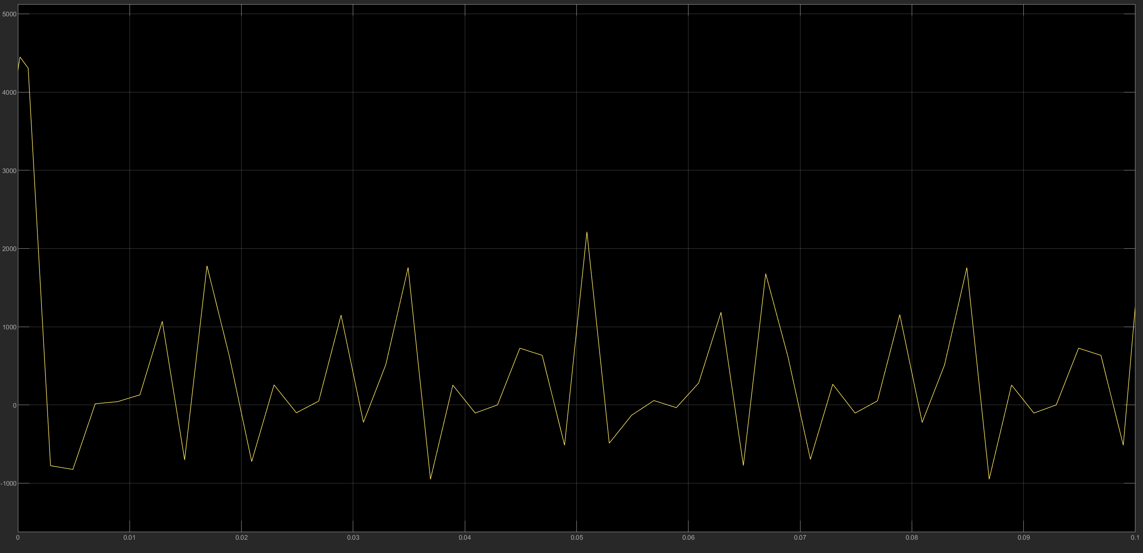
Figure 3 plot of instantenous voltage

